Project Title

Problem Statement
Funeral service providers operate in a high-urgency, emotionally sensitive market where immediate responsiveness is critical. When inquiries occur outside regular operational hours, the business faces severe bottlenecks:
- High Lead Attrition: High-urgency inquiries—particularly those occurring late at night—are frequently missed if the funeral director is unavailable, resulting in immediate loss of time-critical business to competitors.
- Friction in Information Gathering: Bereaved families require clear, immediate, and transparent information regarding service packages. Delays in providing transparent pricing add unnecessary cognitive friction during an already stressful period.
- Complex Service Customization: Funeral arrangements involve numerous variable components (e.g., casket selections, wake durations, religious rites, logistics). Manually compiling these variables into accurate quotes outside business hours introduces major administrative delays.

Key Features & Proposed Solution
- 24/7 Empathetic Conversational Intake: A highly responsive, text-based conversational interface capable of handling late-night inquiries with an appropriate tone, ensuring immediate lead capture and reassurance.
- Dynamic Package & Add-on Q&A: An AI assistant grounded in the company's service catalog, capable of handling complex, variable questions across different religious rites and logistical options.
- Real-Time Dynamic Pricing Rules Engine: An algorithmic engine that instantly calculates precise, transparent quotes as the user selects or modifies service tiers, wake durations, venue locations, and optional add-ons.
- Automated Quotation Generation & E-Sign Pipeline: A programmatic pipeline that compiles the final configuration into an institutional, itemized PDF quote and injects it into a digital signature workflow for instant client confirmation.

Input/Output Data Requirements
- Input Data:
  - Dynamic User Input: Conversational chat inputs, specific package tier choices, customizable add-ons, and family contact details.
  - Static Backend Matrices: Relational database records containing the service catalog, dynamic pricing logic tiers, religious compliance rules, and current resource availability.
- Output Data:
  - Validated, itemized JSON contract payloads, an officially rendered digital quotation PDF, and secure electronic signature status tracking tokens.

Expected Deliverables & Workflow

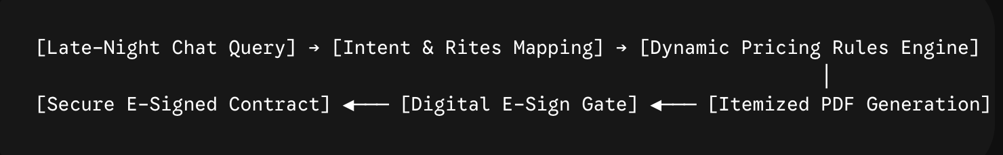
- Client-Facing Conversational Interface: A lightweight, web-compatible chat widget optimized for mobile devices, focusing on fast load times and clean, accessible UX.
- Deterministic Pricing Engine Backend: A microservice responsible for processing configuration JSON payloads against the institutional pricing matrix to output exact cost break-downs without hallucination risks.
- Automated Document Generation Worker: A backend utility that ingests the finalized configuration payload and renders a clean, professional, itemized PDF quotation.
- Electronic Signature & Intake Gateway: A secure integration layer (e.g., via DocuSign, HelloSign, or a self-hosted cryptographic signature canvas) that handles formal quote acceptance, captures timestamps, and triggers an immediate high-priority notification to the on-call funeral director.

